Name – Kaung Sat Paing

Student ID – 14399033

Changes -1

Code origin

Code Changes



Web Origin

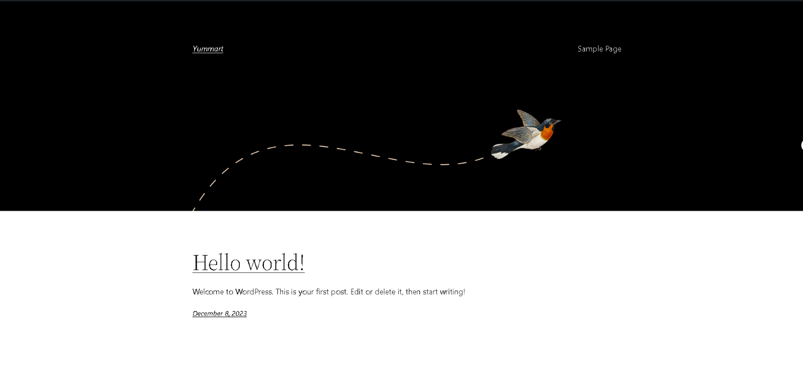

Web Changes

